Jacqueline Jones
Lab 9.1
Bioinformatics

1.3

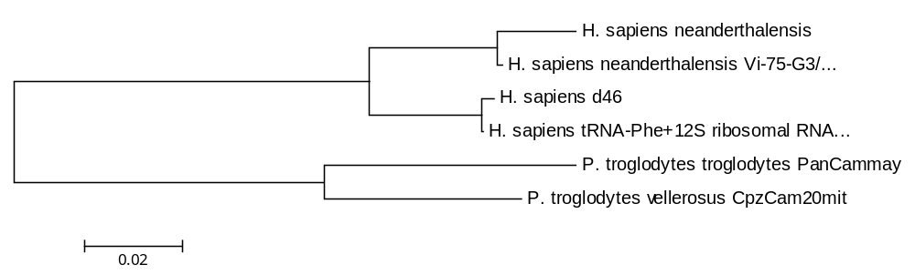

2.2
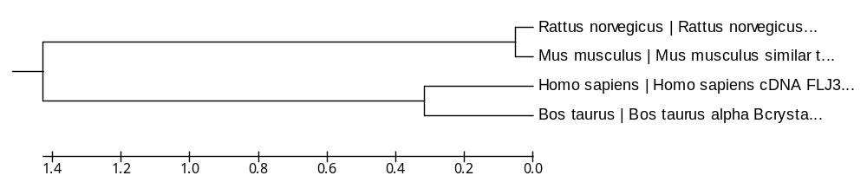
2.3
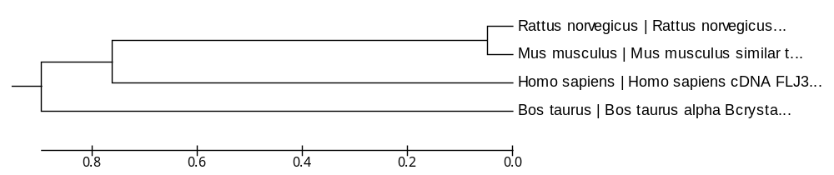
2.4
